LAB 1
- Write a C program to simulate the following CPU scheduling algorithm to find turnaround time and waiting time.

- FCFS
Code:
#include <stdio.h>

int main() {
int n, i;
int bt[20], wt[20], tat[20];
float avg_wt = 0, avg_tat = 0;

printf("Enter number of processes: ");
scanf("%d", &n);

for(i = 0; i < n; i++) {
printf("Enter Burst Time for P%d: ", i+1);
scanf("%d", &bt[i]);
}

wt[0] = 0;

for(i = 1; i < n; i++)
wt[i] = wt[i-1] + bt[i-1];

for(i = 0; i < n; i++) {
tat[i] = bt[i] + wt[i];
avg_wt += wt[i];
avg_tat += tat[i];
}

printf("\nProcess\tBT\tWT\tTAT\n");
for(i = 0; i < n; i++)
printf("P%d\t%d\t%d\t%d\n", i+1, bt[i], wt[i], tat[i]);

printf("\nAverage Waiting Time = %.2f", avg_wt/n);
printf("\nAverage Turnaround Time = %.2f", avg_tat/n);

return 0;
}

Output:
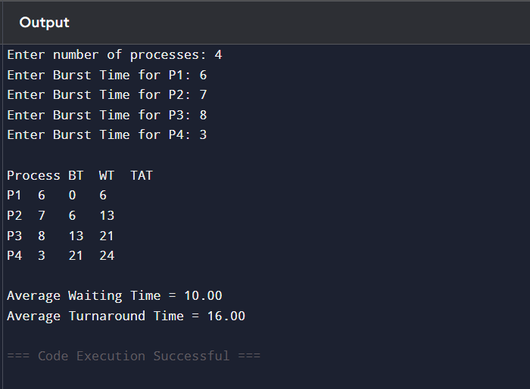

- SJF non preemptive
Code:
#include <stdio.h>

int main() {
int n, i, j;
int bt[20], wt[20], tat[20], p[20];
float avg_wt = 0, avg_tat = 0;

printf("Enter number of processes: ");
scanf("%d", &n);

for(i = 0; i < n; i++) {
printf("Enter Burst Time for P%d: ", i+1);
scanf("%d", &bt[i]);
p[i] = i+1;
}

for(i = 0; i < n-1; i++) {
for(j = i+1; j < n; j++) {
if(bt[i] > bt[j]) {
int temp = bt[i];
bt[i] = bt[j];
bt[j] = temp;

temp = p[i];
p[i] = p[j];
p[j] = temp;
}
}
}

wt[0] = 0;

for(i = 1; i < n; i++)
wt[i] = wt[i-1] + bt[i-1];

for(i = 0; i < n; i++) {
tat[i] = bt[i] + wt[i];
avg_wt += wt[i];
avg_tat += tat[i];
}

printf("\nProcess\tBT\tWT\tTAT\n");
for(i = 0; i < n; i++)
printf("P%d\t%d\t%d\t%d\n", p[i], bt[i], wt[i], tat[i]);

printf("\nAverage Waiting Time = %.2f", avg_wt/n);
printf("\nAverage Turnaround Time = %.2f", avg_tat/n);

return 0;
}

Output:
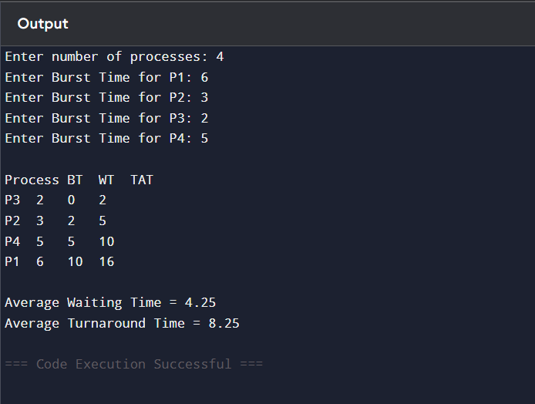

- SJF preemptive
Code:
#include <stdio.h>

int main() {
int n, time = 0, completed = 0, min, shortest = -1;
int bt[20], rt[20], wt[20], tat[20];
float avg_wt = 0, avg_tat = 0;

printf("Enter number of processes: ");
scanf("%d", &n);

for(int i = 0; i < n; i++) {
printf("Enter Burst Time for P%d: ", i+1);
scanf("%d", &bt[i]);
rt[i] = bt[i];
}

while(completed != n) {
min = 9999;
shortest = -1;

for(int i = 0; i < n; i++) {
if(rt[i] > 0 && rt[i] < min) {
min = rt[i];
shortest = i;
}
}

rt[shortest]--;
time++;

if(rt[shortest] == 0) {
completed++;
tat[shortest] = time;
wt[shortest] = tat[shortest] - bt[shortest];
}
}

for(int i = 0; i < n; i++) {
avg_wt += wt[i];
avg_tat += tat[i];
}

printf("\nProcess\tBT\tWT\tTAT\n");
for(int i = 0; i < n; i++)
printf("P%d\t%d\t%d\t%d\n", i+1, bt[i], wt[i], tat[i]);

printf("\nAverage Waiting Time = %.2f", avg_wt/n);
printf("\nAverage Turnaround Time = %.2f", avg_tat/n);

return 0;
}

Output:
